Career Education SD35
WHY Career Education?

Focus of Career Education
Career Education is one of 3 core values of the purpose of education from the BC School Act.
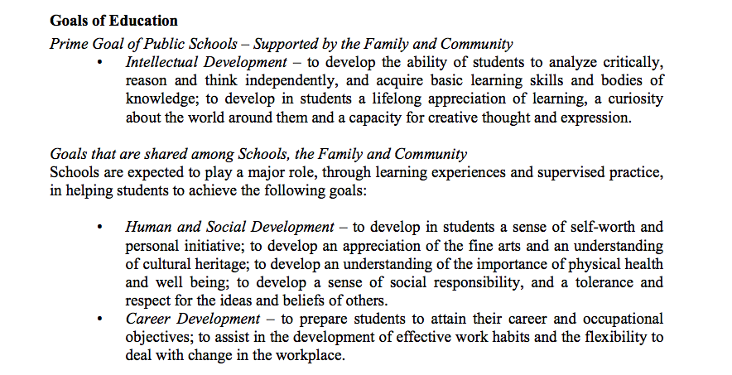

Rationale for Career Education
The Career Education curriculum supports students in the process of becoming successful, educated citizens by providing them with opportunities to explore a variety of work and career pathways and options for their future. Career Education helps students to discover a bridge between classroom learning and workplace and post-secondary realities, and is intended to make learning meaningful and relevant.

Further, the Career Education curriculum provides students with the opportunity to make connections between what they learn in school and the local and global community. The curriculum encourages students to actively pursue new relationships or build on existing relationships with their community. Mentorship, volunteerism, and community and global responsibility form an integral part of the curriculum. Students are encouraged to reflect on their experiences to gain an awareness and understanding of the role they play as individuals in supporting and strengthening their communities.

The Goals of Career Education
The Career Education curriculum contributes to students’ development as educated citizens through the achievement of the following goals. Students are expected to
- develop awareness of their individual skills, interests, values, and passions, and connect them to career goals
- work and communicate effectively with others, valuing diversity of people and cultures, ideas, and opportunities
- understand the role of learning in supporting their career goals and be prepared to continue learning and developing new interests, knowledge, and skills throughout their lives
- recognize the need to be adaptable, resilient, and flexible in order to meet the changing demands of the work environment
- recognize the necessity of safety standards in the workplace
- understand the value and importance of career development to individual lives, communities, society, and the global economy
- identify and research education and career pathways, and explore a range of career experiences, including volunteering and non-traditional approaches to work
- effectively use goal-setting and decision-making strategies to develop, manage, and adjust their educational and career plans
The Career Development Process
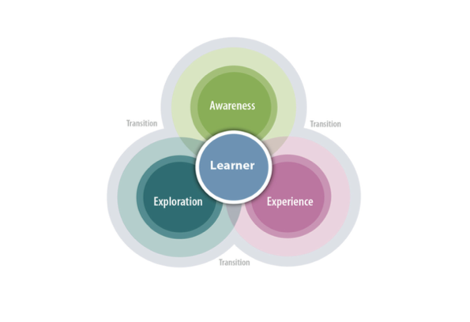

Career Education is a process that recognizes three major phases of career development—Foundation & Awareness, Exploration, and Experience & Application. Students will transition through each phase based on their personal development and community contexts/needs.

As students move through Grades 10–12, they further refine their understanding of the links between personal development and their work/career decisions. They will consider regional and global trends to reflect on career possibilities, refine their understanding of safety requirements associated with occupational areas and related technologies, and further develop and refine their understanding of career possibilities through planning, practice, and application of competencies and knowledge.

Students may explore and experience various career options before they discover the most appropriate and meaningful direction for them. For some students, a successful transition will involve a direct path to further education, while for others it will involve a direct path to the world of work. During these years, students will develop a very personalized transition plans, which may include workplace experience and all graduates will complete and present a capstone project.
Career Education Courses: Starts earlier!
2 new key points:
- Career Education is now a K-12 curriculum for all 12 years of a student’s educational process!
- The Career Curriculum K-9 is meant to be embedded where every teacher is a career educator.
- The Career 10-12 Courses are specialized in class courses which are mandatory for graduation in BC.

Career Education K–12 is a redesigned provincial curriculum that focuses solely on the competencies and content required for career development. In the past, Career Education was part of the Health and Career Education Program: (HACE) K–9, Planning 10, and Graduation Transitions 12. The review of all curricular areas has resulted in the health curriculum being combined with physical education to create a new, holistic Physical and Health Education curriculum. The new Career Curriculum is now K-12. K-9 content is embedded in regular classroom learning but is reported separately and courses are in place for Career Life Education 10, Career Life Connections 11 and the Capstone requirement in grade 12.

In addition, the new curriculum addresses the concern often expressed by students, educators, parents, employers, and post-secondary institutions that a student’s career development education needs to begin at a much earlier age. Career development is an ongoing process that requires a variety of explorations and experiences both within and outside the school environment; the result is a full career education curriculum from K-12.

Career Curriculum Courses
- Career Education K-7 (embedded content)*
- Career Education 8 (course or embedded content)*
- Career Education 9 (course or embedded content)*
- Career Life Education (CLE) 10/11 (replaces Planning 10) + Career Education conversations should be happening in every content area.
- Career Life Connections (CLC) 11/12 (replaces Grad Transitions 11/12) + Career Education conversations should be happening in every content area.
- Capstone 12 + Career Education conversations should be happening in every content area.

*Career Education conversations should be happening in every content area.
Career Education 8

In Grades 6–9, students explore concepts such as identity, leadership, personal planning, and transferable skills. As students build on the foundation developed from their experiences in K–5, they begin to explore in greater depth their skills and passions, and begin to determine possible routes to their goals.

Big ideas:
- Reflecting on our preferences and skills helps us identify the steps we need to take to achieve our career goals.
- The value of work in our lives, communities, and society can be viewed from diverse perspectives.
- Achieving our learning goals requires effort and perseverance.
- Adapting to economic and labour market changes requires flexibility.
- Our career paths reflect the personal, community, and educational choices we make.

Career Education 9

In Grades 6–9, students explore concepts such as identity, leadership, personal planning, and transferable skills. As students build on the foundation developed from their experiences in K–5, they begin to explore in greater depth their skills and passions, and begin to determine possible routes to their goals.

Big ideas:
- Reflecting on our preferences and skills helps us identify the steps we need to take to achieve our career goals.
- The value of work in our lives, communities, and society can be viewed from diverse perspectives.
- Achieving our learning goals requires effort and perseverance.
- Adapting to economic and labour market changes requires flexibility.
- Our career paths reflect the personal, community, and educational choices we make.

Career Life Education (CLE) 10/11

Career Life Education (CLE) is a course that recognizes three major phases of career development—Foundation and Awareness, Exploration, and Experience and Application.
As students move through Grades 10–12, they further refine their understanding of the links between personal development and their career decisions. They consider regional and global trends to reflect on career possibilities, refine their understanding of safety requirements associated with occupational areas and related technologies, and further develop and refine their understanding of career possibilities through planning, practice, and application of competencies and knowledge.

Big Ideas
- Finding a balance between work and personal life is essential to good physical and mental health.
- A network of family, friends, and community members can support and broaden our career awareness and options.
- Learning how to learn prepares us to be lifelong learners who can adapt to changing career opportunities.
- Effective career planning considers both internal and external factors.
- The global economy affects our personal, social, and economic lives and prospects.
- Successful career and education paths require planning, evaluating, and adapting.

Career Life Connections (CLC) 11/12

As students move through Grades 10–12, they further refine their understanding of the links between personal development and their career decisions. They consider regional and global trends to reflect on career possibilities, refine their understanding of safety requirements associated with occupational areas and related technologies, and further develop and refine their understanding of career possibilities through planning, practice, and application of competencies and knowledge.

Students may explore and experience various career options before they discover the most appropriate and meaningful direction for them. For some students, a successful transition will involve a direct path to further education, while for others it will involve a direct path to the world of work. During these years, students will develop their transition plans, which may include workplace experience and a final capstone project.

Big ideas
- Well-being requires finding a balance of personal health, relationships, work, learning, community engagement, and committed citizenship.
- Being in the world and walking in the world are supported, broadened, and deppened through community involvement and the social experience of building personal networks.
- Careers, education, and life opportunities change over time.
- Building the skills of lifelong learning can help us adapt and thrive.
- Global economies, culture, and sustainable impact and are impacted by personal choices, and the availability of personal choices.

Capstone: 12
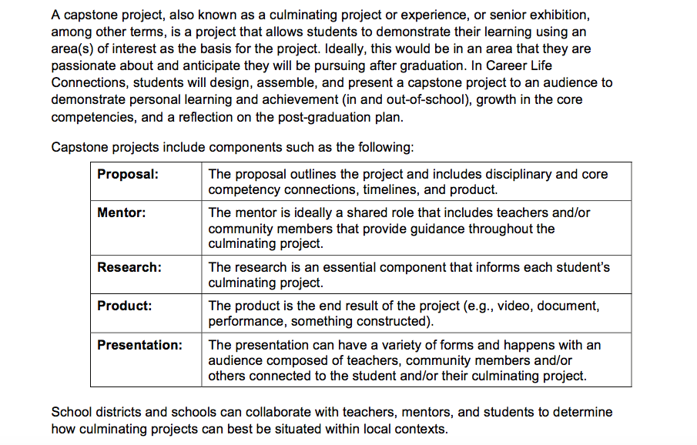

Curriculum in relation to Career Education

Core Competencies | Facets
Critical Thinking
- Analyze and Critique
- Question and Investigate
- Develop and Design
Creative Thinking
- Novelty and value
- Generating Ideas
- Developing ideas
Communication
- Connect and engage with others
- Acquire, interpret and present information
- Collaborate to plan, carry out and review constructions and activities.
- Explain/ recount and reflect on experiences and accomplishments

Positive Personal and Cultural Identity
- Relationships and cultural contexts
- Personal values and choices
- Personal strengths and abilities
Personal Awareness and Responsibility
- Self determination
- Self regulation
- Wellbeing
Social Responsibility
- Contributing to community and caring for the environment
- Solving problems in peaceful ways
- Valuing diversity
- Building relationships

Career Education in relation to the KDU Model

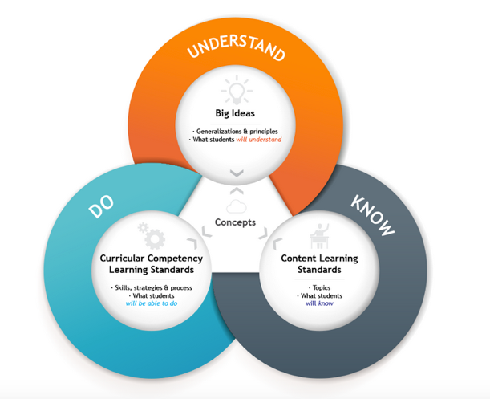
Understand | Big Ideas | - Successful career and education paths require planning, evaluating, and adapting.  - A network of family, friends, and community members can support and broaden our career awareness and options.
Do | Curricular Competencies | - self-awareness: Use self-assessment and reflection to consider their post-graduation goals and plans  - working with others (collaboration and communication): recognize the influence of their communication skills and digital footprint on job-seeking  - career knowledge and awareness: Demonstrate ethical behaviour, equality, and equity within a work environment  - career planning: Create, evaluate, adjust, and present a career and education plan, including a financial plan
Know | Content | Life and Career Plan

UNDERSTAND: Big Ideas
The Big Ideas represent what students are expected to understand as a result of their learning — the “Understand” component of BC’s learning model. Collectively, the Big Ideas progress in both sophistication and degree of connection to the lives of students throughout the curriculum. The examples below show how the Big Ideas about personal development and connections to community advance as students progress through the curriculum.
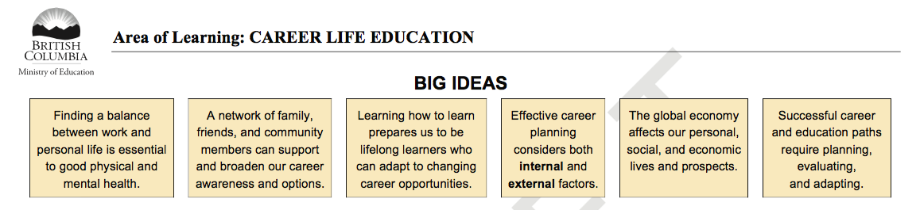

DO: Curricular Competencies
Curricular Competencies are action-based statements that reflect the “Do” component of the curriculum model and identify what students will do to demonstrate their learning. The Curricular Competencies have been written to promote as much flexibility and creativity as possible, enabling students to explore and find multiple ways to demonstrate their learning.
The Curricular Competencies connect to the Core Competencies—Communication, Thinking, and Personal and Social. Identified and developed through provincial consultation, the Core Competencies are the intellectual, personal, social, and emotional skills that will contribute to lifelong learning. The curricular competencies in the Career Education curriculum focus particularly on the Personal and Social Competencies.

The Curricular Competencies are designed to address four themes that run through the curriculum:

- self-awareness: Use self-assessment and reflection to consider their post-graduation goals and plans
- working with others (collaboration and communication): recognize the influence of their communication skills and digital footprint on job-seeking
- career knowledge and awareness: Demonstrate ethical behaviour, equality, and equity within a work environment
- career planning: Create, evaluate, adjust, and present a career and education plan, including a financial plan

KNOW: Content
The Content learning standards reflect the “Know” component of the learning model and are stated as topics. The Content acts as both a supporting structure intended to assist students in demonstrating the Curricular Competencies and is a foundational element leading students to the Big Ideas. The content of the Career Education curriculum is organized under two headings in K-5: Personal Development and Connections to Community. Starting in Grade 6, a third heading is added to focus on the development of graduation plans: Life and Career Plan.

