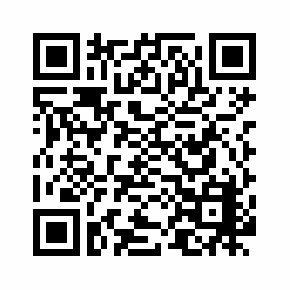
Interested in an easier way for your students to access their All About Me Portfolio?

Want to learn more about the different QR code options for logging in through a Web browser or the Class Pass App?

This guide is for you!
- What is a QR code?
Security and Privacy Warning: Student and Class Pass QR codes are like passwords. Please keep them secure, and remind your students never to share them on social media. In the event a code is lost, see the last section of this guide for instructions how to reset it.
QR stands for ‘Quick Response’ – a QR code is like a barcode, made up of black squares in a grid. The squares encode information which can be quickly read by a device with a camera. These codes are often scanned with a code reader app, but to log in to All About Me Portfolio with a QR code, you’ll simply need to use a Web browser (e.g., Google Chrome, Internet Explorer) or our Class Pass app for iOS and Android. Download the Class Pass app (Google Play or Apple App Store) from your app store today and get started!
- How can students use a QR code to log in?
Before getting started, you’ll need to decide if the student will be logging in through a Web browser or the Class Pass App for iOS and Android.

Not sure which to use? Here are a few options for you to consider:
  - If you’ve got access to an iOS or Android device, and you’d like multiple students to be able to post media to their portfolios using the same device, you will want to use option #1 – log in to Class Pass using the Class QR code
  - If you’d like students to be able to post artifacts as smoothly as possible to their own portfolios, and each student will have access to their own iOS or Android device, you will go with option #2 – log in to Class Pass using an individual student QR code
  - If you want your students to have full access to view and edit their portfolios, you will choose option #3 – log in with an individual student QR code through a Web browser

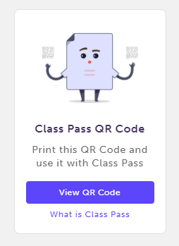
- Option 1: Log in to Class Pass using the Class QR code

- First, generate the QR code for your class:

  - Visit www.myBlueprint.ca, click Log In at the top right corner, and log in to your Teacher Account
  - Click on your Class
  - Click View QR Code in the Class Pass QR code box on the right
  - Print the QR code with the Print button, or leave it up on your screen to scan from the app using an iOS or Android device
- Next, open the Class Pass app on your iOS or Android device:
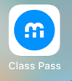
  - Tap the Class Pass icon
  - Tap Scan QR code
  - Point the camera at the QR code until you receive the green ‘Success!’ message

- That’s it! Your whole class is now logged in to the app and students can start posting to their portfolios.

  - After adding any media, students will be prompted to select their name to add the post to their portfolio
  - You’ll need to log in to your Teacher account using a Web browser to approve students’ posts before they appear in each student’s portfolio

- Security / Privacy: If a Class Pass QR code is lost in a public place, you can preserve the security of your students’ data by:

  - Clicking View QR Code in the Class Pass QR code box
  - Click Reset – this will generate a new QR code for your class, and invalidate any previously-generated code

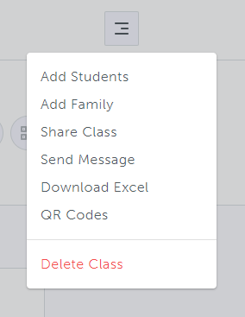
- Option 2: Log in to Class Pass using an individual student QR code

- First, generate the individual QR code for your student(s):

  - Log in to your Teacher account and click on your class box
  - Click the menu button (three lines) at the top right corner
  - Select QR Codes
  - Download the code for an individual student with the Download Student QR button, or click Download All to download all codes at once
    - The codes will download as PDFs, which can be scanned off the screen or printed

- Next, open the Class Pass app on your iOS or Android device:
  - Tap the Class Pass app icon
  - Tap Scan QR code
  - Point the camera at the QR code until the green ‘Success!’ message appears

- That’s it! Your student is logged in to the Class Pass app and can start posting media to their portfolio.
  - Posts made from the app with an individual student login are posted directly to their account, without requiring teacher approval

*Pro Tip: The student will need to tap the gear icon in the top right corner of the app, then Logout before another student can use the app on that device

- Option 3: Log in with an individual student QR code through a Web browser

- The steps to generate the student QR code are the same as for Option 2 above:
  - Log in to your Teacher account and open your class
  - Click the menu button (three lines) at the top right corner
  - Select QR Codes
  - Download the code for an individual student with the Download Student QR button, or click Download All to download all codes at once
    - The codes download as PDFs which can be scanned off the screen or printed

- Next, open a Web browser - we recommend Google Chrome - on a device with a camera:
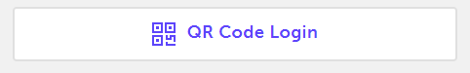
  - Visit www.myBlueprint.ca
  - Click Log In
  - Select QR Code Login
  - Point your camera at the QR code (or hold the QR code sheet up to the camera) until you receive a ‘Success!’ message

- You’re all set! Your student is logged in to their All About Me Portfolio in exactly the same way as if they had logged in using their regular username & password.

- Resetting a QR code
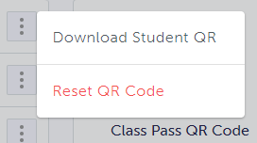
If one of your students loses track of a printed QR code, follow these steps to preserve the security of their account:
- Click the menu button (three lines) at the top right corner
- Select QR Codes
- Click the ‘three dots’ button to the right of the student’s name
- Select Reset QR Code – this will invalidate any previous QR code and generate a new one
More of a visual learner?
Watch this very short video demonstrating the log-in process through a Web browser!
http://bit.ly/aamqrcodes

